SOFT OFFER
USED RAIL R50-R65 ISRI 27-29
To: Potential Buyer

Throgh: Asian Dragon International

Dear Sirs,
We, on behalf and authorized by the Seller or its representatives, wish to confirm, with full corporate responsibility, that we are ready, willing and able to transact and provide the commodity of Scrap Metal Used Rails R50-R65 under the following specifications, terms and conditions. Sales and purchase will be based on International procedures.

1.  2. | COMMODITY  SPECIFICATIONS | USED RAIL R50-R65 As per ISRI 27 to 29  The seller herewith confirms that the scrap consists of Scrap used rails ISRI R50 (51.67kg/m GOST 7173-75, R65 (64.72 kg/m GOST 8165-75) ISRI Codes 27-29, rails are straight length of 6 to 12 m (+/- 5%).continuous welded rails .Free from mud. Wood dust fluff. Non ferrous, excessive rust & other impurities (max 1%) and non radioactive. Scrap Steel to be supplied under the present contract shall conform with steel scrap specifications and standards of the Institute of Scrap Recycling Industries (ISRI) and shall be strictly limited to used rails and scrap steel to the standards specifically set out below:  a) R50-R65: used long rail steel scrap in compliance with ISRI standard classification R50 (51.67 kg/m), Suitable for re-rolling into bars and shapes. Free from bent and twisted rails, frog, switches, and guard rails, or rails with split rail.  b) R65: used long rail steel scrap in compliance with ISRI standard classification R65 (64.72 kg/m) or ISRI Code 200 through 202, in length from Six (6) meters to Twelve (12) meters on per bar basis, Suitable for re-rolling into bars and shapes. Free from bent and twisted rails, frog, switches, and guard rails, or rails with split rail.  c) All scraps shall be free of explosive and oily materials and woody substance in any event.  COMPOSITION:  Carbon 0,20—0,60%  Manganese 0,60—0,90%  Silicon 0,15—0,35%  Sulphur Max.0,03%  Phosphorus Max. 0, 03%  .

3. | PHOTO | 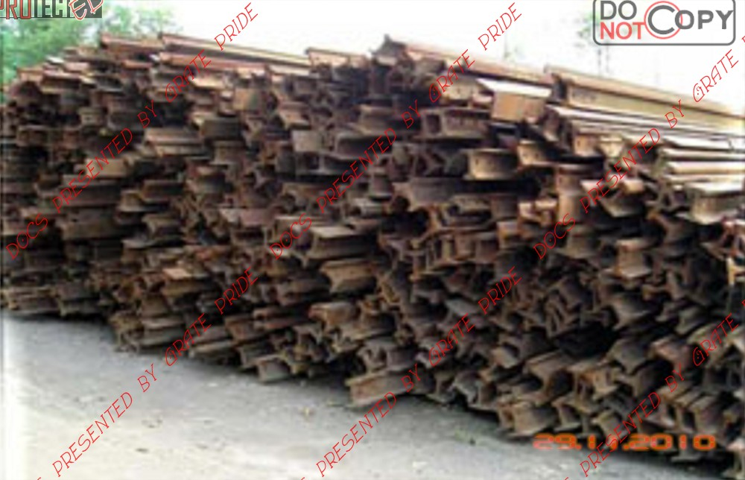
4. | ORIGIN | United Kingdom, Europe or Seller’s option
5. | LOADING PORT | Nottingham or seller’s option
6. | QUANTITY | 30,000 MT X 12 months with 1st shipment as trial
7. | UNIT PRICE | USD322 per Metric tons
8. | CONTRACT VALUE
9. | CONTRACT PERIOD | 12 months
10. | MONTHLY VALUE
11. | DISCOUNT | NONE
12. | PACKAGING | Bulk
13. | LENGTH | 6 to 12 Meters
14. | DISCHARGE PORT
15. | INSPECTION | Inspection shall be at port of loading by SGS appointed by Seller under supervision of the Buyer’s representative. Other than SGS is welcome on Buyer’s cost.

16. | PROOF of PRODUCT | Full Proof of Product shall be provided by the Seller within 10 days after Seller receipt of the operative financial instrument confirmed to seller’s bank. The Seller shall then issue to buyer verifiable proof of products Certificates detailing allocation of stocks batch numbers, Quantity, weight, Charter Party Agreement, Export License and Insurance binder covering this contract quantity under executed contract number via bank to bank.
17. | PAYMENT TERMS | An irrevocable, fully funded, transferable Letter of Credit payable 100% at sight against documents at loading port. The Letter of Credit shall cover the value of one shipment and is subject to approval by the SELLER’S APPOINTED BANK. All bank charges accrued at the Buyer’s bank regarding the opening of the Letter of Credit are for the buyer’s account.
18. | PERFORMANCE BOND | Seller shall post an Operative Performance Bond amounting to Two percent (2%) of the monthly shipment value and POP via bank to bank and shall be issued within Ten (10) banking days after receipt of the buyer’s Operative financial instrument to the Seller’s Bank. Verbiage of the Letter of Credit must be acceptable to the Seller.
19. | NCND | This agreement includes by reference and incorporates the Standard International Non-Circumvention Agreement and conditions as set forth by International Chamber of Commerce (ICC Publication 500, revision 1994) and pertains to any introduction of persons or product to Buyer/Seller by Buyer/Seller or Seller/Buyer’s agents at any stage for a period of five (5) years from date hereof.  This document binds all parties, their employees, associates, transferees, relations, assignees or designees. Fax copies of this document are fully legal, enforceable and binding.
20. | CORRESPONDENCE | All correspondence to be addressed and sent to Asian Dragon International sales@asiandragonintl.com

PROCEDURES
- The Buyer reviews the final contract and upon acceptance signs the final copy contract and returns it to the Seller. If further revisions are required they are noted and sent back to the Seller for further review.

- Upon receipt of the accepted signed draft contract from the Buyer via facsimile or Email, a table top meeting shall be arranged for the final signing of the contract. During the meeting the Seller shall present reference documents to the Buyer.

- Before the payment instrument is SWIFT to the Seller’s designated bank account, the verbiage of the said instrument must be reviewed and approved by the representative of the Seller and notification of the approval shall be sent to the Buyer.

- Within ten (10) banking days after the Final contract has been signed, The Buyer shall issue the operative or non operative payment instrument through the Buyer’s bank as reviewed and approved by the Seller’s designated bank account.

- Within ten (10) banking days after receipt of the operative or non operative payment instrument issued by Buyer’s bank acceptable to the Seller and the Sellers Bank, the Seller shall issue a full Proof of Products as per Clause 12.

- Within ten (10) banking days after receipt of operative financial instrument acceptable to the Seller and the Sellers Bank, the Seller shall issue a 2% Performance bond as per Clause 11.

- Seller will invite Buyer for loading visit at the loading port.

- Delivery and shipment shall commence after the fulfillment of the procedure, stated above, as per the terms and conditions of this contract.

If you are agreeable to the terms and conditions of the above offer, kindly issue LOI and BCL BEFORE the expiry date of this offer. Any response after the expiry date may be subject to a new pricing.

